**Introduction**

This is the design process of a relational database for a doctor surgery developed in Microsoft Access. Patients, doctors, and appointment data will be managed effectively by the database. The management of healthcare services and patient care along with scheduled maintenance of individuals can only be efficiently achieved via a professionally designed database. The steps that were followed in creating the database, tables, inserting sample data, creating relationships, queries and reports, and data validation that were performed are discussed in the coming sections.

**Types of databases**

Relational Database

Relational database is a form of structured database that stores the data in interrelated tables with data to be stored and retrieved and organized through using relationships with primary and foreign keys.

**Characteristics**

• Tabular data model: Data is organized as in tables, in rows and columns.

• Relationships give you strong data integrity: They ensure your data is accurate and consistent.

• Advanced Querying through SQL: Allow the complexities of queries to be supported through Structured Query Language (SQL).

**Tools and Techniques**

• Table: data is organized into tables and relationships are established between them.

• Field Attribute: Data fields with pre-defined data types and sizes as well as validation rules.

• Indexing: Speeds Up Data Retrieval

• Queries — SQL command to filter, sort and fetch elements according to certain setting

Productivity, Precision and Usability Benefits

• Relationship between table via enforced relationship is the reason of remains accuracy of data.

• Complex querying features provide targeted data visibility.

• Access control and relationships help maintain high security and data integrity.

**Strengths and Weaknesses**

Strengths: Data accuracy, complexity of query and security

Weakness: It can't scale easily; it is quite setup complex and resource demanding.

**Cloud Database**

A cloud database is regarded as an online database, which is hosted on cloud infrastructure and provides the most significant advantage of being able to access that from multiple places and enables dynamic scaling according to resource needs.

**Features**

• Access while on the go: Can be accessed from any location as long as you have an Internet connection.

• Easy to Scale, More Flexible: You can quickly scale in or out depending on your requirements.

• Managed data backup and recovery: It gives you the advantage of automatic backups and managed recovery processing.

**Tools and Techniques**

• Data Management: The onsite maintenance will be reducing because of the setup is managed by a cloud provider.

• Indexing and Sharding: The use of techniques such as sharding by the providers to ensure quick scalability.

• Queries: SQL or NoSQL (depending on the platform & use case)

Advantages in Efficiency, Precision and Ease of Use

• With scalability and remote access, you can work from anywhere with internet access.

• Data availability is ensured through reliable storage with automated backups.

• Less IT management since the infrastructure is managed by a cloud provider.

Strengths and Weaknesses of cloud database

Strengths: It is very cost-effective, scalable and has remote access.

Weaknesses: Internet dependency: it has limited control over data location and management.

**Purpose of the Database System**

The relational database will provide a user-friendly, secure, efficient system for the management of patient records and appointment scheduling at a doctor's surgery. The system will enhance the old, cumbersome paper-based and spreadsheet system to: store patient details-name, address, contact information.

Manages appointment details, such as date, time, assigned doctor, and purpose.

Generate meaningful reports and queries for better decision-making.

**Here is my Structure Chat**

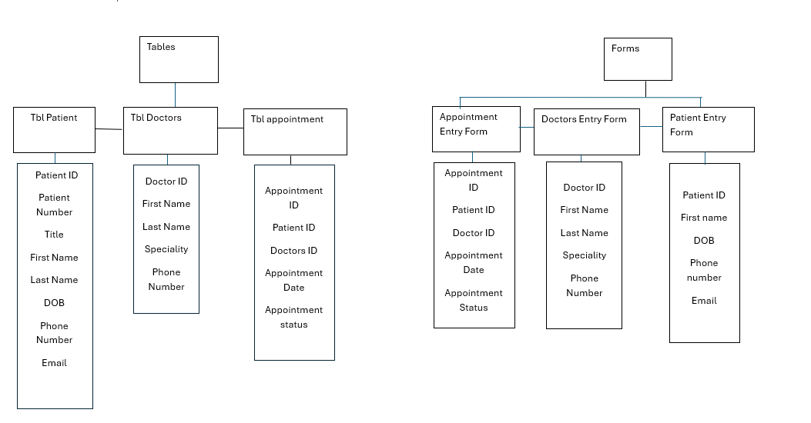

**Tables**

**Table 1:**  Patients

**his table will be used to store data like patient ID, First Name, Last Name, Date of Birth, Gender, Address, and contact information for the patients. You should have appropriate field sizes so that your data is entered correctly, and you cannot enter data that should not go in there.**

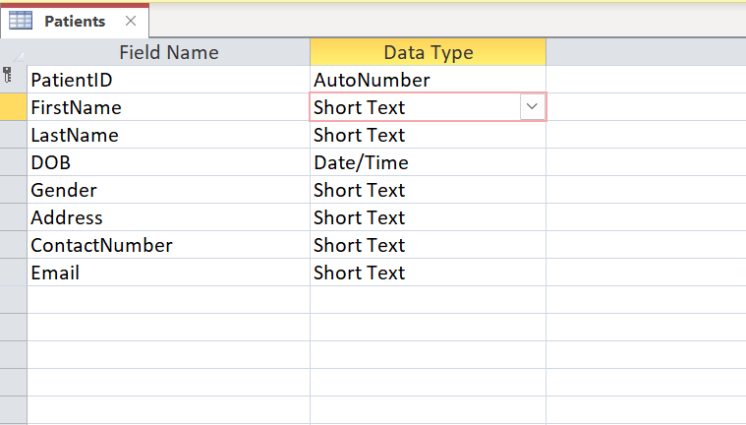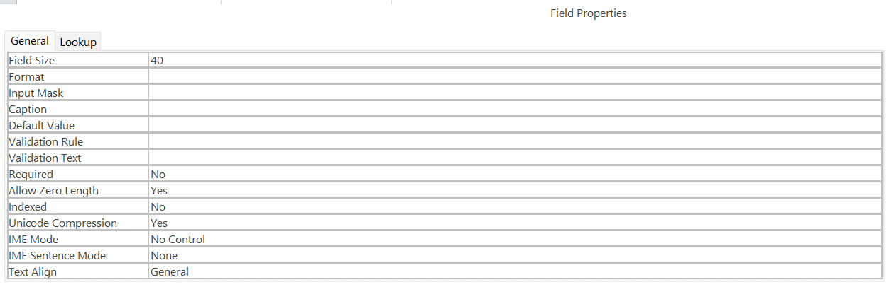

I am limiting the field size by 40.

Preview of Patients List

**Preview of my Patients table**

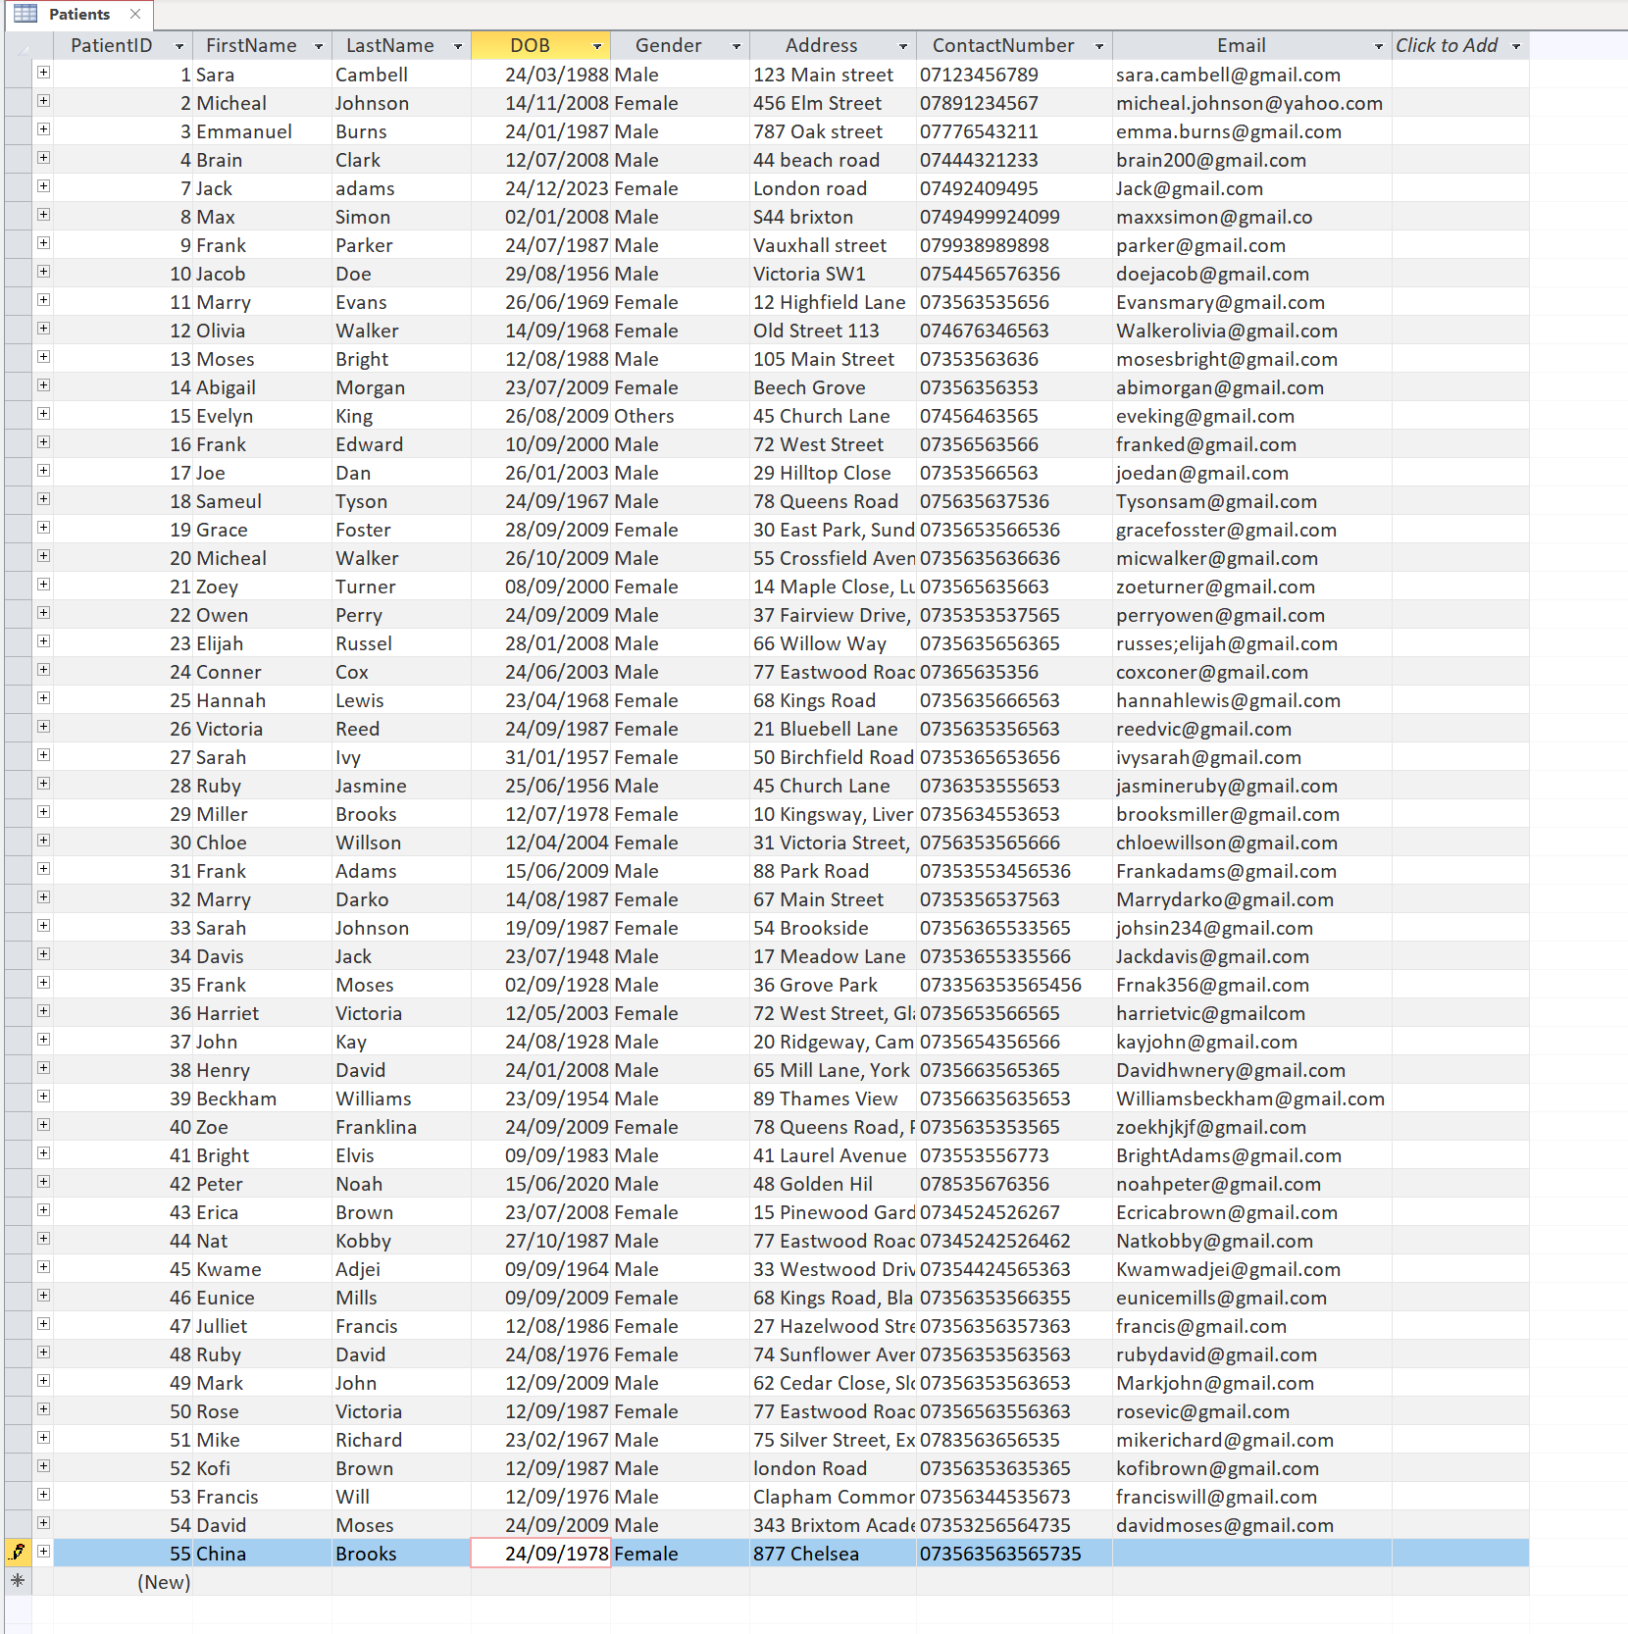

**Table 2:** Appointments

**The Appointments table links patients with the doctor and information about appointment times. The foreign keys ensure the relationship between patient and doctor is maintained The Appointment table stores the appointment date, time, and its provider.**

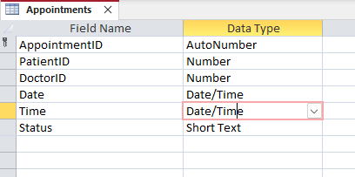

I made the Validation Rule <Date()

Which means all dates must be today or in the future.

**Preview of Appointments Table**

**Table 3: Doctors table**

**This table shows info about the doctors who work with the surgery. It helps us keep track of their specialties and how to contact them. Having the phone numbers in the same format keeps everything looking neat.**

I filled out the Doctors table with details for each doctor. This way, we can easily link them to appointment records. Making sure the contact info looks the same helps the database look more professional.

**Preview of my Doctors table**

**Table 4: Appointment Schedules Table**

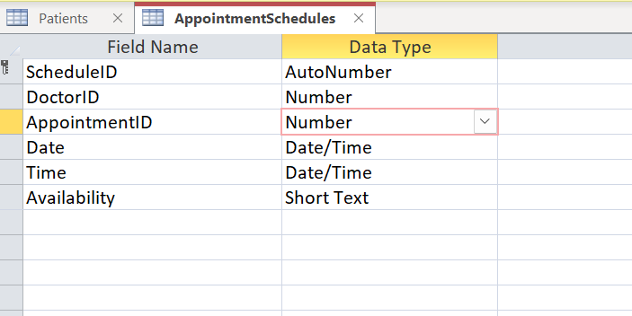

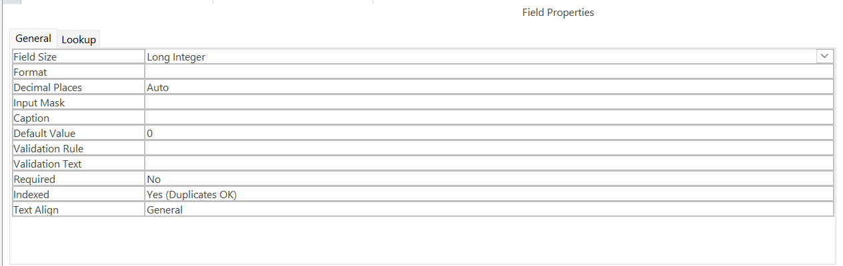

**Table 5: Patient Record Table**

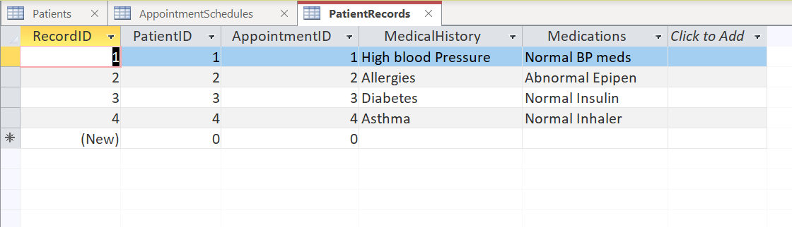

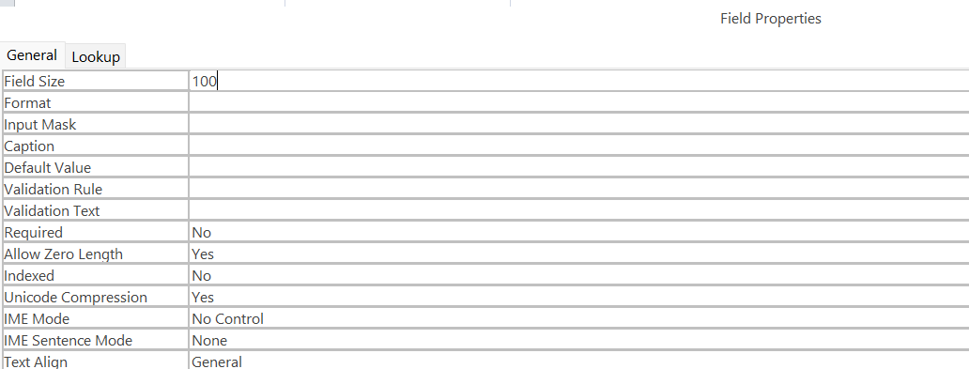

**Database Integrity Checks**

Patients Table

I have limited the field size for Address.

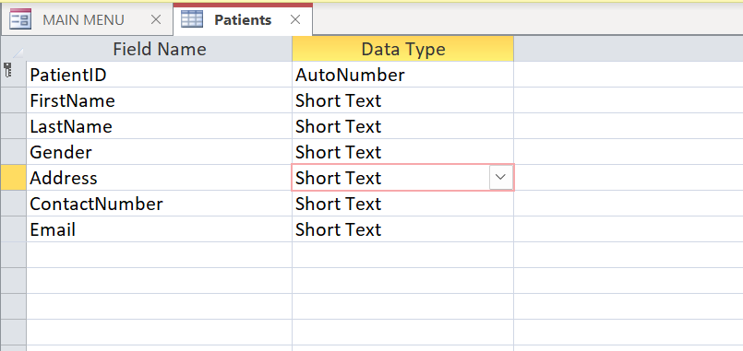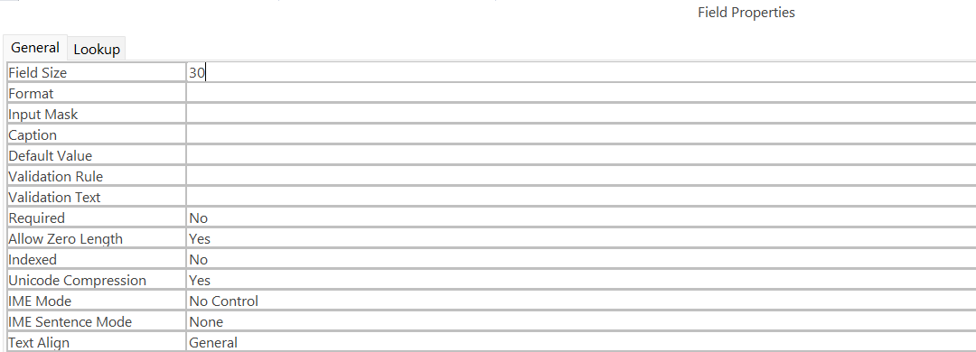

I am limiting the field size to 30 characters for Address.

I have set an input mask on the Date of Birth

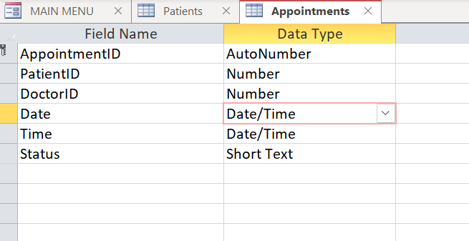

I have used an input mask DD/MM/YYYY

This appears as 99/99/0000;;

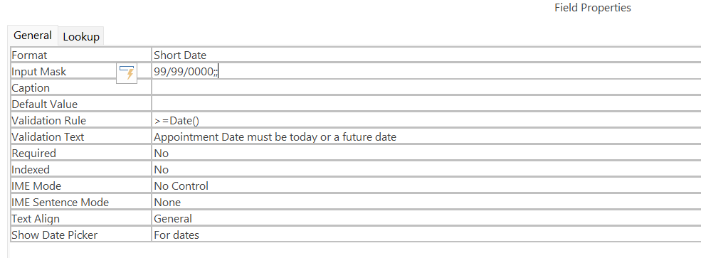

I have set a validation rule on the Data of Birth

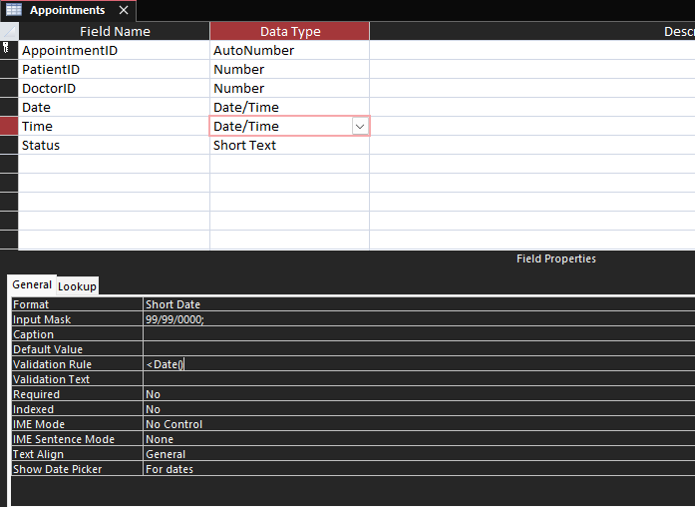

I have used a validation rule.

This appears as <Date()

This makes sure that the user cannot enter a date in the future.

It must be less than today’s date as my error message shows on the form. I set this error message us using validation text.

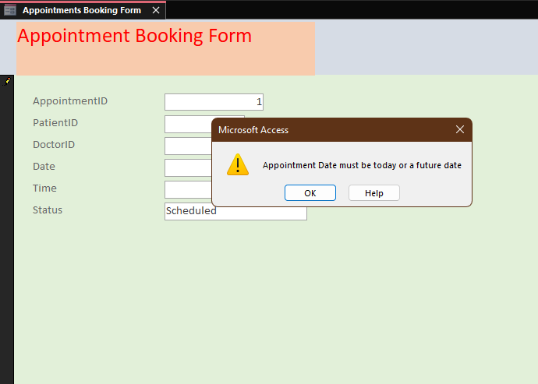

I have used a combo/list box to make sure the user enters only the data I want.

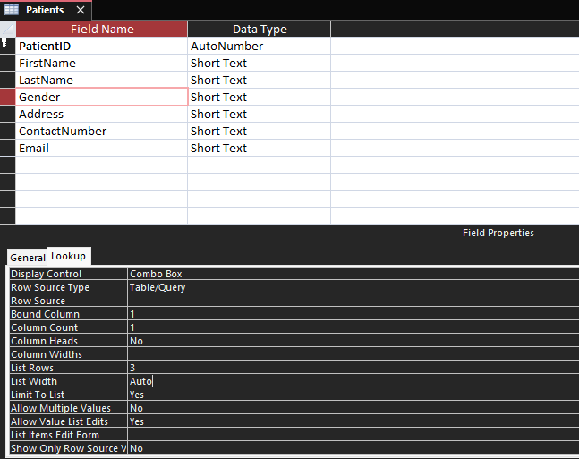

I have used a combo box.

The user can only enter the values in the combo box.

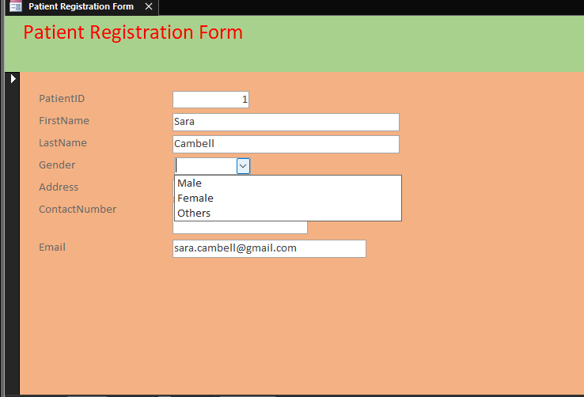

This is my combo box working on my form.

**Relationships**

I have created a one-to-many relationship.

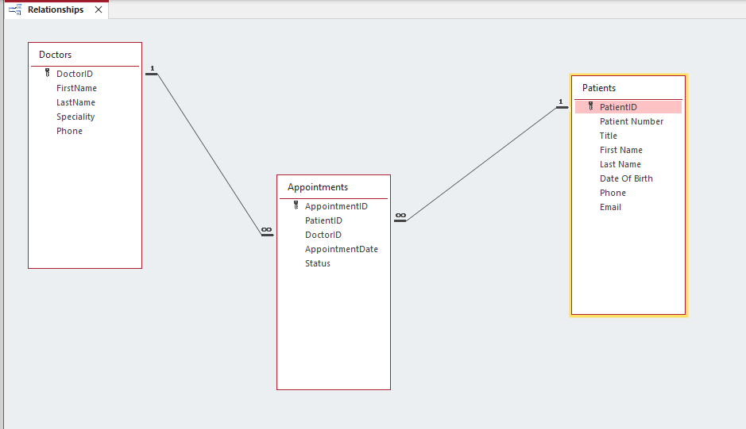

**Forms**

**Form 1:** MAIN MENU

This would, in turn, mean a more centralized and user-friendly interface through which a user would be able to manoeuvre in different functionalities of the database-for instance, adding new patients or pulling reports-and also opens from start-up. These are custom buttons that simplify such processes and ensure the quick access of users to most-used features. The "Exit" button gives the users a straightforward way to close this database. This addition enhances user experience by providing an effortless and accessible way to quit the application without having to go away from the Main Menu.

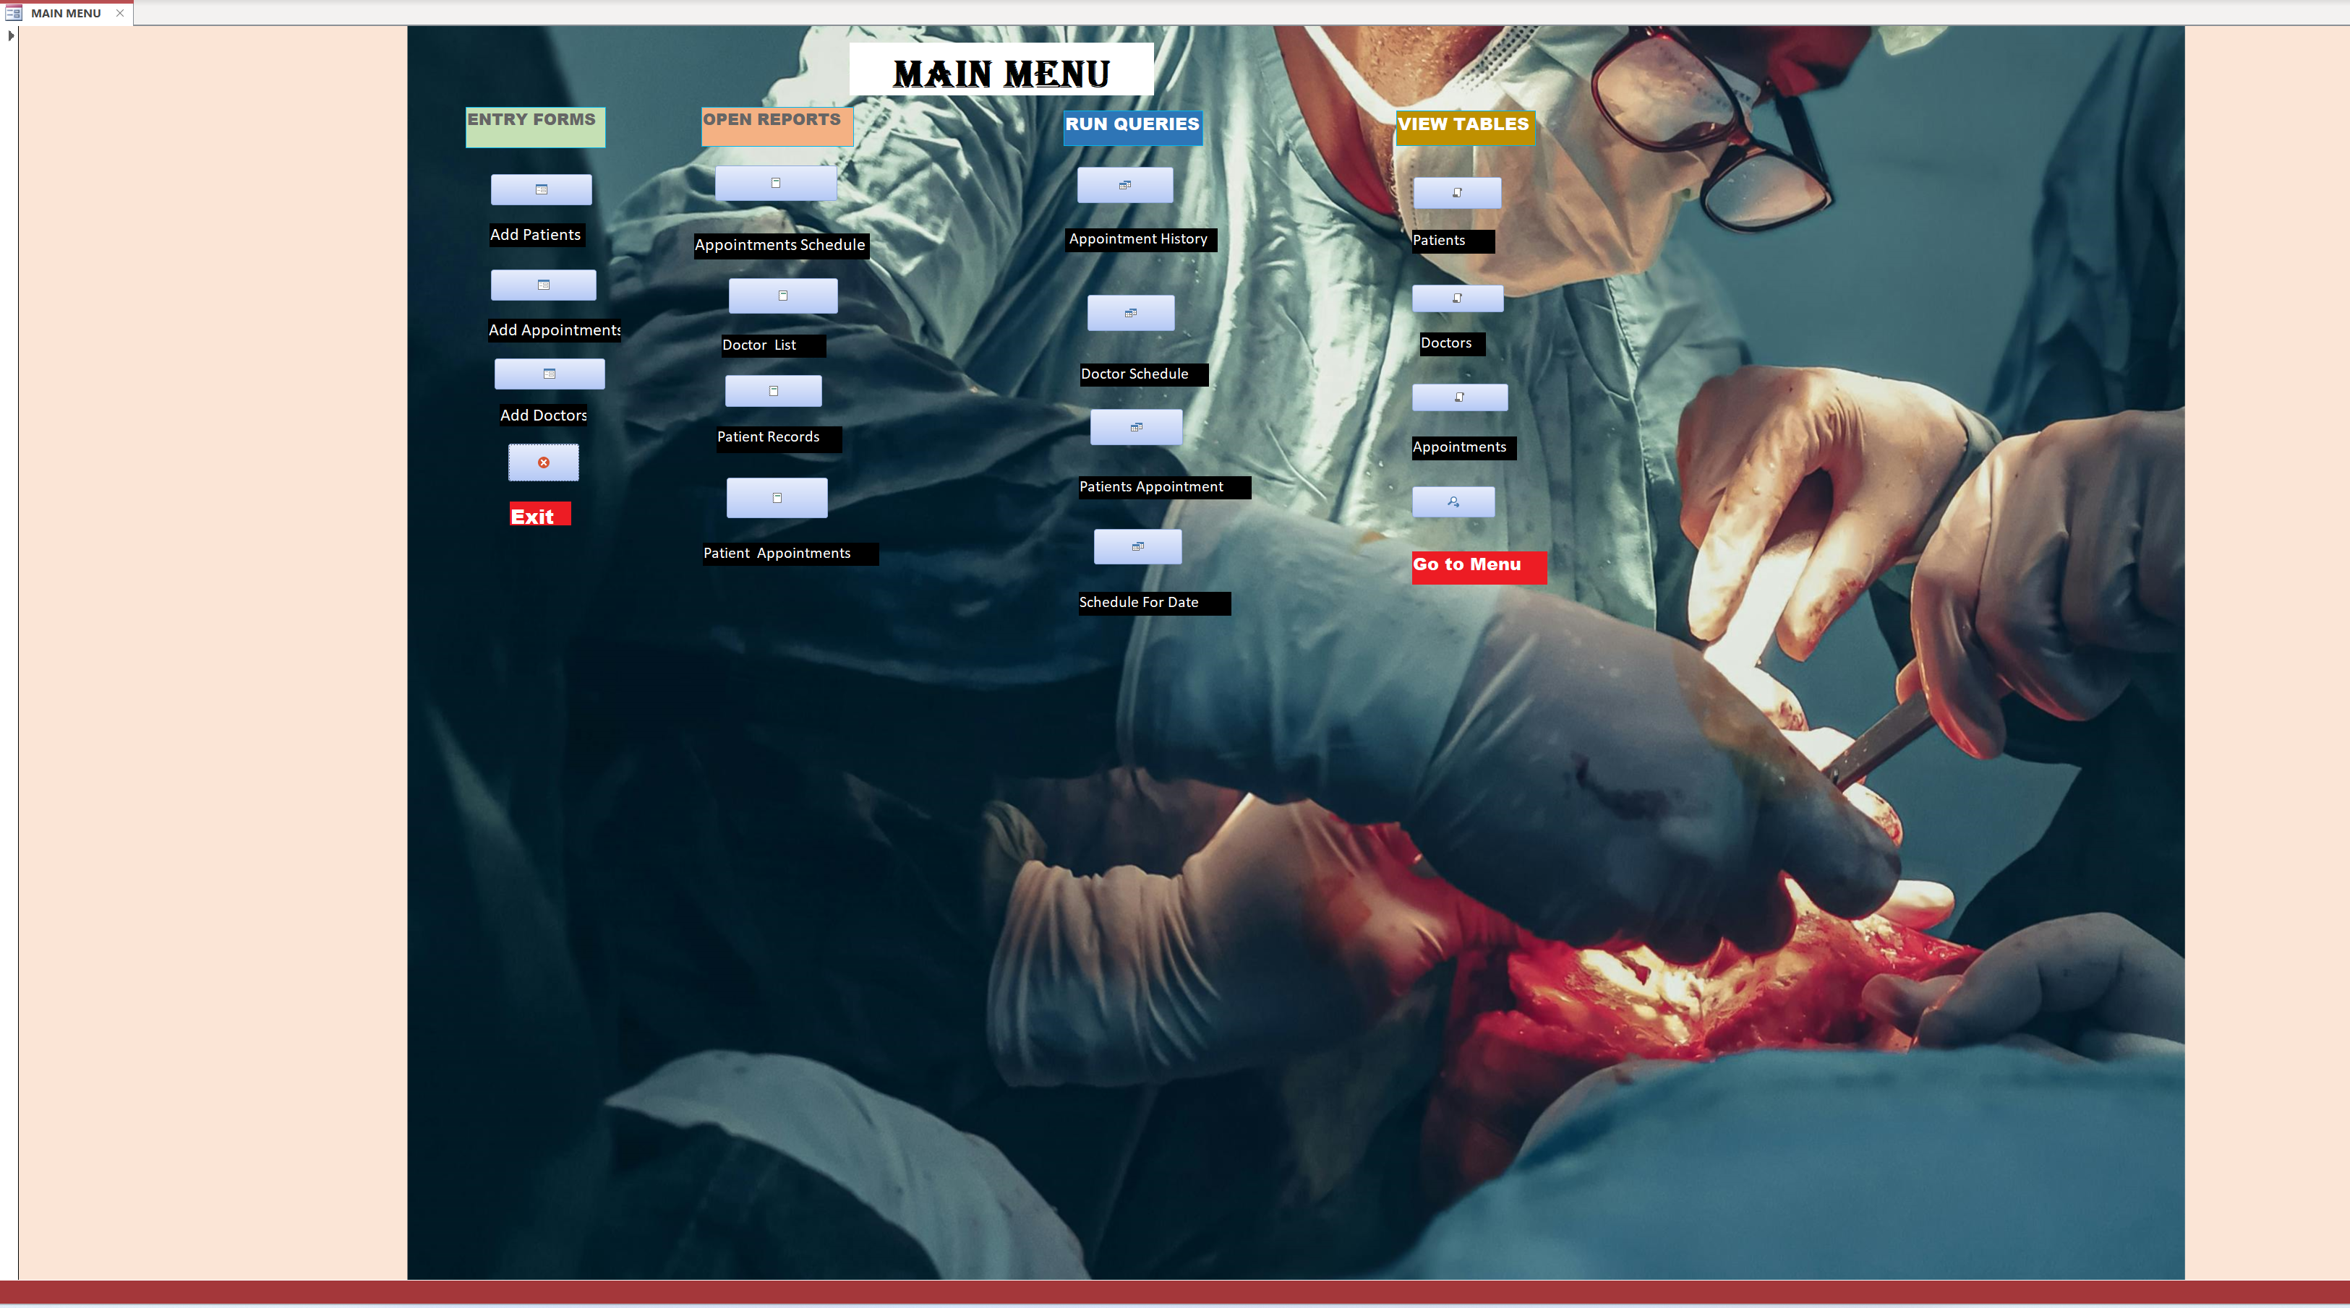

**Form 2:** Patient Registration Form

This form allows clinic staff to register new patients and update existing patient information. The Patient Registration form is designed to be user-friendly, with clear labels and intuitive navigation. The form validates user input to ensure data accuracy and consistency.

**Form 3: Appointment Schedule Form**

This form allows clinic staff to schedule new appointments and manage existing appointments. The Appointment Scheduling form is designed to be efficient, with features such as date and time pickers and provider drop-down lists. The form validates user input to ensure data accuracy and consistency.

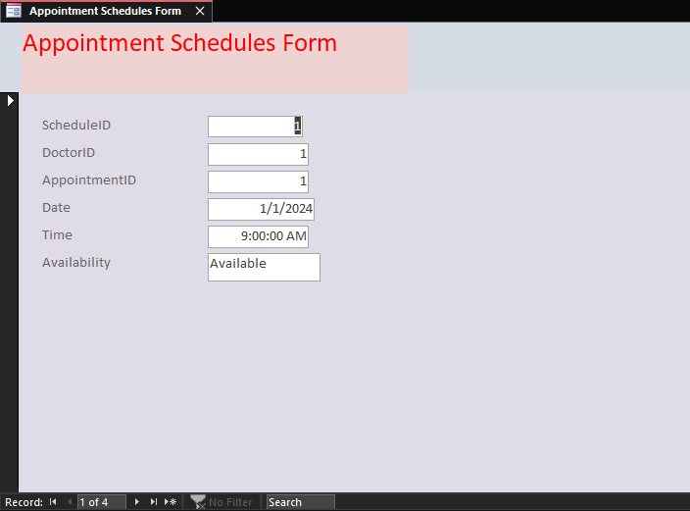

**Form 4: Patient Records Form**

The patient record form should contain the Record ID, Patient ID, Appointment ID, Medical History, and Medications. It provides a unique identification, connects appointments to patient records, contextualizes treatment, and keeps track of medications to avoid drug interactions that support efficient and safe healthcare management.

**Form 5: Appointment Booking Form**

The aim of this database is to manage and track appointments effectively. Every appointment is identified with an Appointment ID, which connects the booking with the Patient ID and Doctor ID of the patient and the healthcare provider, respectively. Date and Time fields are included for specifying the appointment, while the Status field defines the appointment status-confirmed, pending, or cancelled. This system helps in streamlining scheduling, avoiding conflicts, and proper coordination between patients and healthcare providers.

**Form 6: Doctors Schedule Form**

A doctor's schedule form is used to organize a healthcare provider's availability for patient appointments. It keeps track of the doctor's working hours, dates, and appointment slots to ensure that there are no scheduling conflicts. This form helps in organizing the patients' bookings, optimizes the doctor's time, and enhances general clinic or hospital operations by clearly showing the doctor's availability. It also assists in managing appointments, reducing scheduling errors, and enhancing patient care.

**Queries**

**Query 1: Appointment History Query**

The purpose of this query is to provide clinic staff with a way to view a patient's appointment history, including past appointments and cancelled appointments. This can be useful for tracking patient appointment history, identifying patterns of missed appointments, and identifying opportunities for improvement.

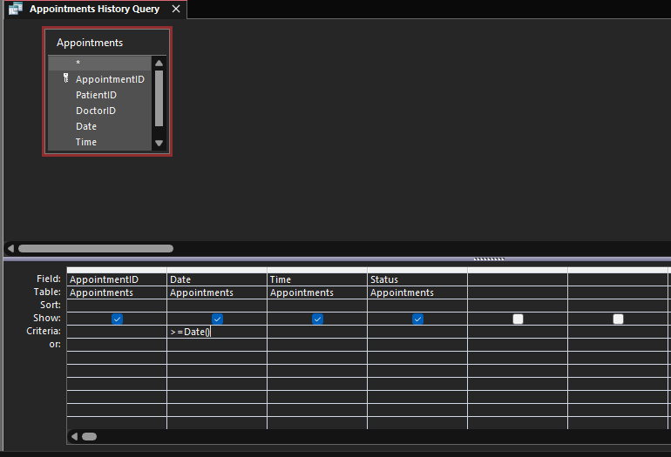

**Preview of my Query**

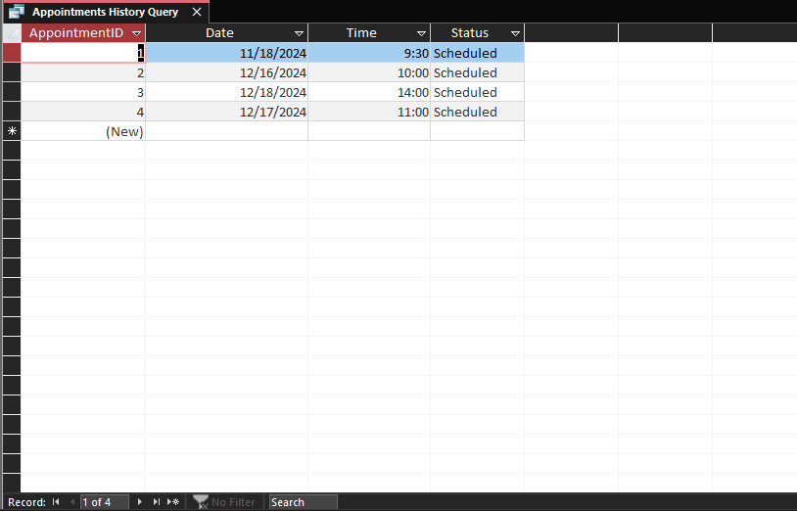

**Query 2: Doctor Schedule Query**

the purpose of this query is to provide clinic staff with a way to view a doctor's schedule for a specific date, including available time slots and scheduled appointments. This can be useful for scheduling new appointments, tracking doctor workload, and identifying available time slots.

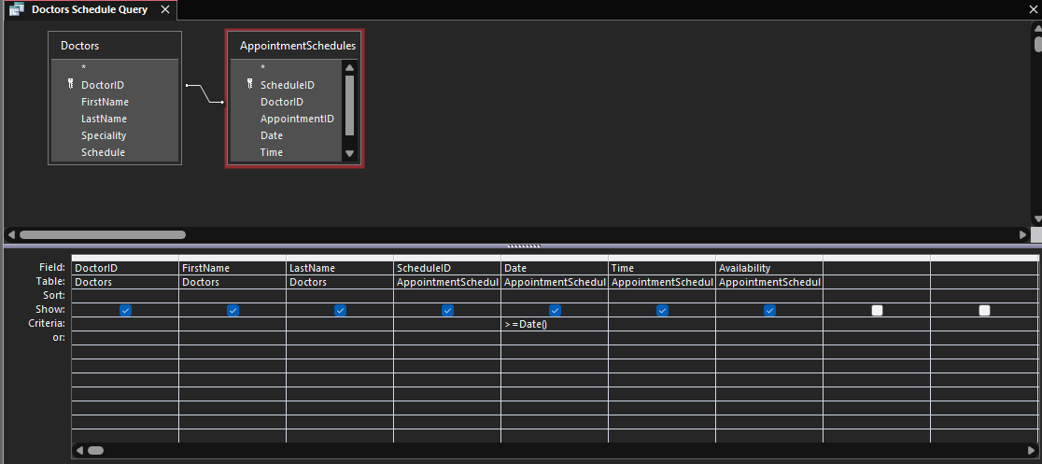

**Preview of my Query**

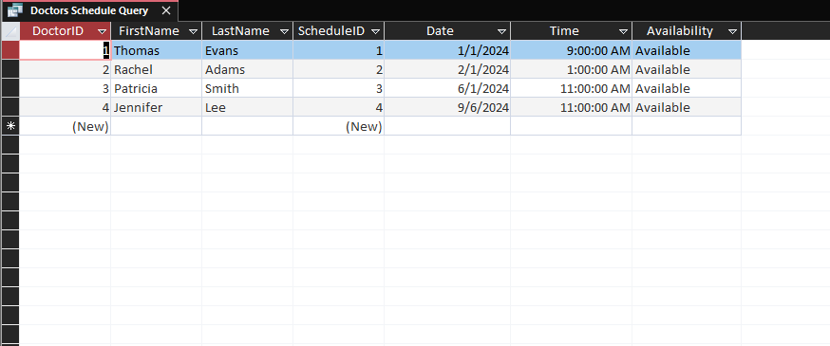

**Query 3: Patients Appointment Query**

The purpose of this query is to provide clinic staff with a quick and efficient way to view a patient's upcoming appointments. This can be useful for scheduling new appointments, cancelling, or rescheduling existing appointments, and tracking patient appointment history.

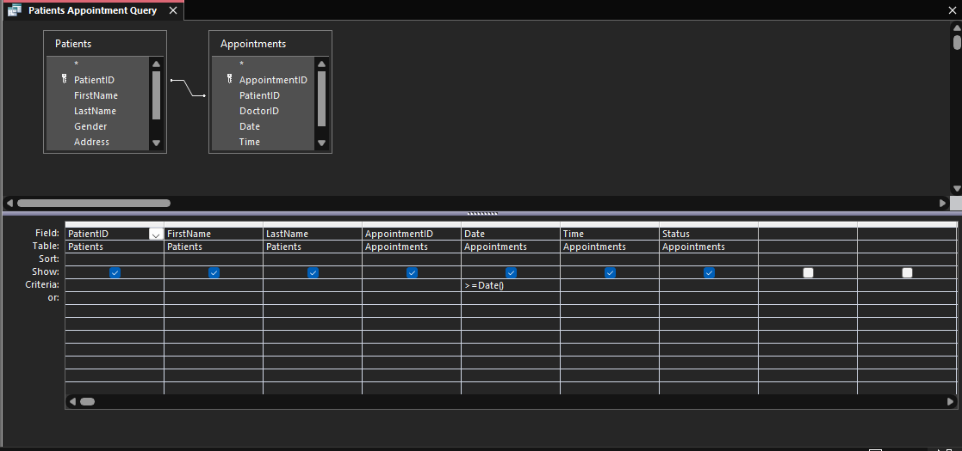

**Preview of my Query**

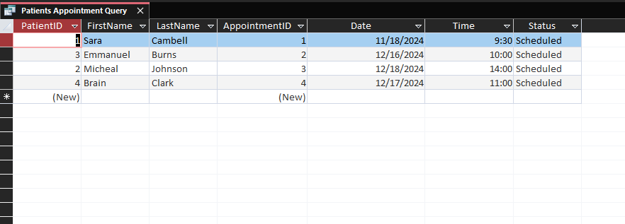

**Query 4: Schedules for Date Queries**

This query gives as the date, time, and availability of patients.

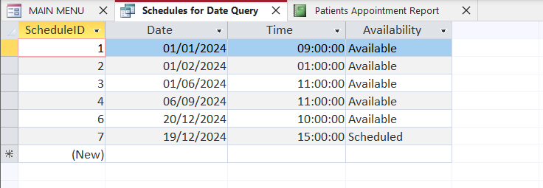

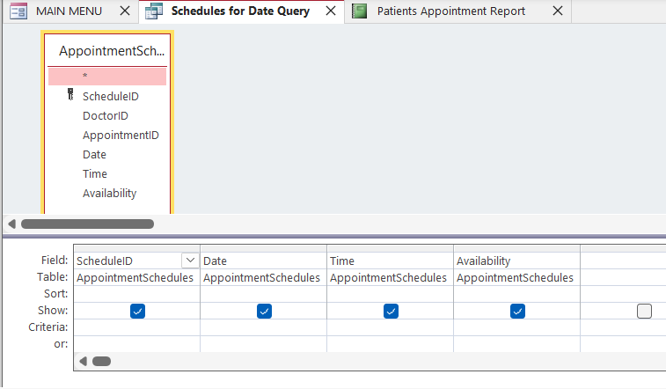

**Reports**

This report includes fields such as patient name, date of birth, contact information, medical history, and test results. The report is designed to provide a comprehensive view of each patient's records, making it easier for healthcare professionals to track their patients' progress and make informed decisions.  
  
I used the Report Wizard in Microsoft Access to create the report, which allowed me to easily design the layout and format of the report without writing any code. I chose to include a variety of fields and controls on the report to make it informative and user-friendly.

**Report 1: Appointment Schedule Report**

The purpose of this report is to provide clinic staff with a way to view the appointment schedule for a specific date, including the patient’s name, appointment time, and provider. This can be useful for tracking appointments, identifying available time slots, and managing clinic workflow.

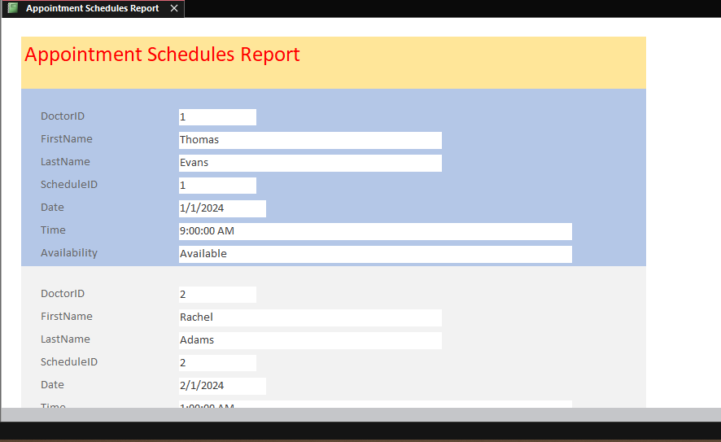

**Report 2: Patient Appointment Report**

**This report provides us with patient details and the time and status of their appointments.**

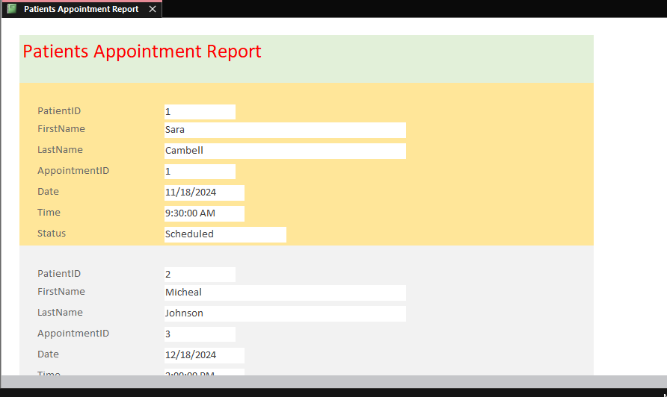

**…**

**Reports 3: Doctors List Report**

This report is used to list all the doctors in a healthcare facility, along with their names, specialties, contact information, and schedule. It aids in scheduling, managing the assignment of doctors, and making sure that patients are matched with appropriate specialists.

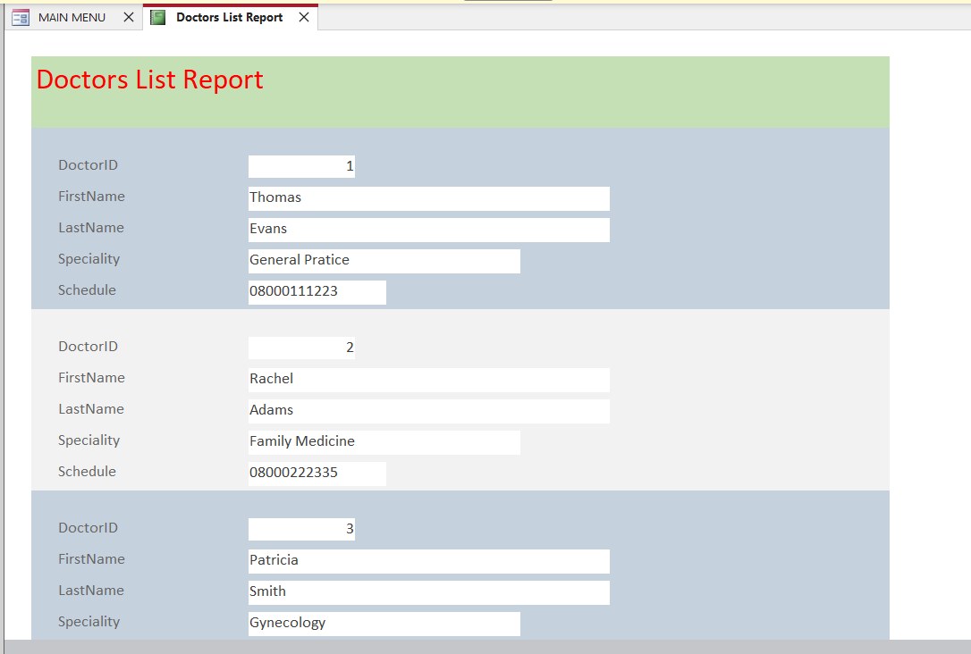

**Report 4: Patient Records Report**

This report is used to document and track patient information, including medical history and medications.

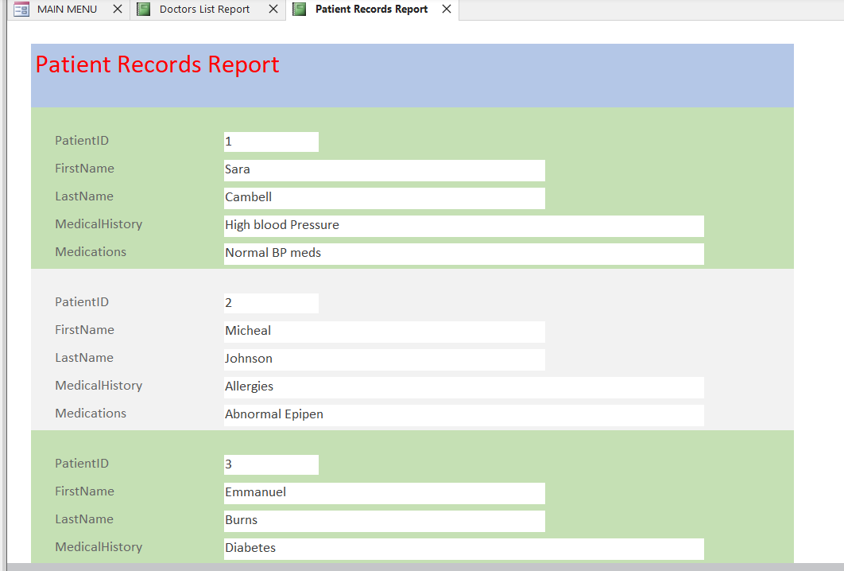

**Macros**

**Macro 1: MAIN MENU MACRO**

The macro is designed to be user-friendly, with clear labels and intuitive navigation. The macro allows users to navigate to different sections of the system, including patient records, appointments, billing, and reports.

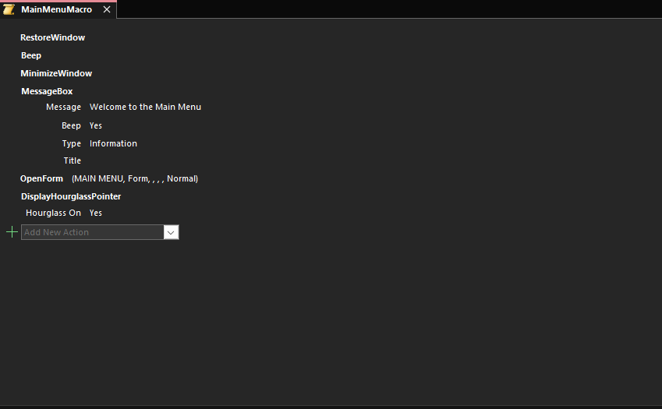

**Setting up Main Menu Macro**

The macro was successfully created and set up to run when the "Go To" button is clicked on the Main Menu form.

**Preview of button properties.**

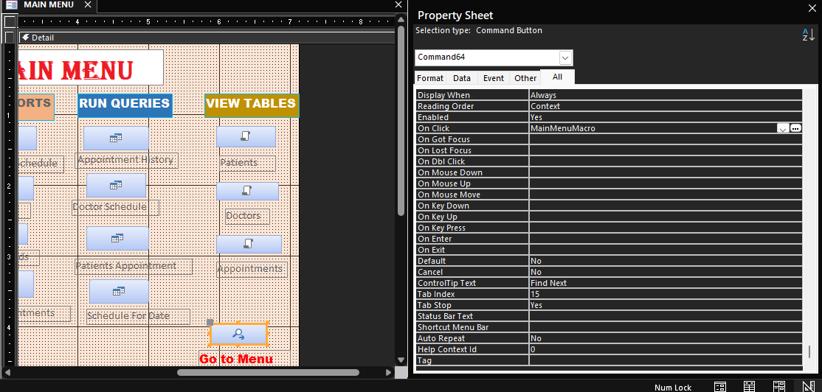

**Macro 2: Appointment Table Macro**

This macro lets us to open and view the datasheet of the Appointment Table.

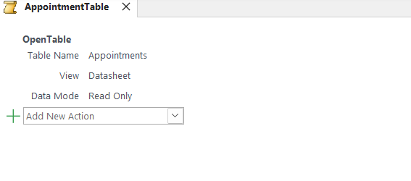

**Macro 3: Doctor Table Macro**

This macro lets us to open and view the datasheet of the Doctor Table.

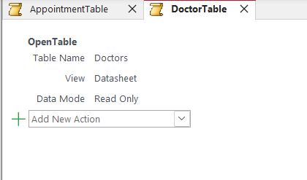

**Macro 4: Patient Table Macro**

This macro lets us to open and view the datasheet of the patients Table.

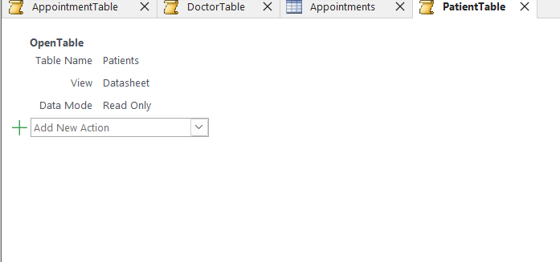

**Doctor Surgery Test Plan**

|  |  |  |  |  |
| --- | --- | --- | --- | --- |
| **Purpose of Test** | **Test Data** | **Expected Results** | **Actual Results – Screen Shots** | **Comment** |
| **Main Menu Tests** | | | | |
| **Entry Forms**: the entry forms have a section of forms which under it. These forms **are Add Patients, Add Appointments, Add Doctors.** The purpose of this Test is to check if each form is clicked it will open to the actual forms. | Add Patients, Add Appointments, Add Doctors. | To open to the actual forms of each of them |  |  |
|  |  |  |  |  |
|  |  |  |  |  |
|  |  |  |  |  |
|  |  |  |  |  |
|  |  |  |  |  |
| **Data Integrity and Validation Checks** | | | | |
| **To make sure our integrity and validations is working** |  |  |  |  |
|  |  |  |  |  |
|  |  |  |  |  |
|  |  |  |  |  |
|  |  |  |  |  |
| **Create Records Tests** | | | | |
|  |  |  |  |  |
|  |  |  |  |  |
|  |  |  |  |  |
|  |  |  |  |  |
| **Navigation Button Tests** | | | | |
|  |  |  |  |  |
|  |  |  |  |  |
|  |  |  |  |  |
| **Queries and Report Tests** | | | | |
|  |  |  |  |  |
|  |  |  |  |  |
|  |  |  |  |  |
|  |  |  |  |  |
| **Macros and Advanced Features Tests** | | | | |
|  |  |  |  |  |
|  |  |  |  |  |
|  |  |  |  |  |

**Justification of Final Design**

The final relational database design was chosen to meet the user requirements and intended purpose effectively while addressing potential constraints. The **one-to-many relationship** between the **Patients** table and the **Appointments** table ensures that patient data is not duplicated, improving both **data integrity** and **efficiency**. Custom-built **forms** for patient and appointment entry simplify data input, reducing errors through validation rules, such as input masks for phone numbers and date restrictions. The **queries** and **reports** provide meaningful insights, such as doctor-specific schedules and patient appointment summaries, which align with the need for efficient data retrieval.

**Conclusion**

This comprehensive guide outlines the steps for creating a Doctor’s Surgery Database using Microsoft Access. This includes setting up tables with structures, entering sample data, establishing necessary relationships, creating queries, generating reports, and implementing data validation to ensure integrity. The report reflects a systematic approach to designing and managing a relational database within a practical healthcare context. Moreover, there are several areas for future improvement or further development of the database, including the following: Application of online appointment scheduling allows patients to schedule their appointments through a web portal. Deploy an automated reminder system for patients by SMS or email about upcoming appointments. Improve data security to safeguard sensitive information pertaining to patients and maintain compliance with healthcare regulations.